# Install Jenkins

1. Open a browser and go to: <https://console.cloud.google.com>
2. From the menus bar select Project🡪Create Project  
   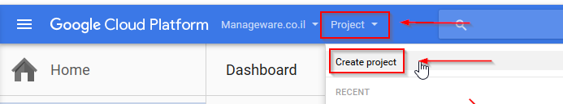
3. Give the project a name and click “Create”  
   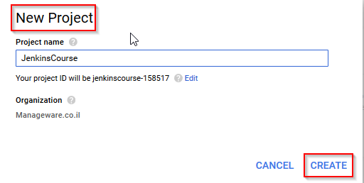
4. From the menu bar click “Activate Google Shell Cloud” button and wait until the shell finish to load.  
   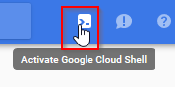
5. In the shell type “vim install”
6. Copy the following text to the vim editor:  
   wget -q -O - https://pkg.jenkins.io/debian/jenkins-ci.org.key | sudo apt-key add -  
   sudo sh -c 'echo deb http://pkg.jenkins.io/debian-stable binary/ > /etc/apt/sources.list.d/jenkins.list'  
   sudo apt-get update  
   sudo apt-get install -y jenkins  
   sudo apt-get install -y npm  
   sudo apt-get install -y node
7. Exit and save: Esc🡪:x🡪Enter
8. Change the script mode to execute:  
   chmod 755 install
9. Run the script:  
   ./install
10. Start the Jenkins service: sudo service jenkins start
11. To open Jenkins Web UI click the “Web preview” button and select “Preview on port 8080”  
    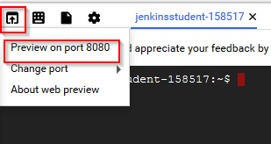
12. Cat the file /var/lib/jenkins/secrets/initialAdminPassword, copy its content to the “Administrator password” field and click “Continue”

Using: sudo cat /var/lib/jenkins/secrets/initialAdminPassword  
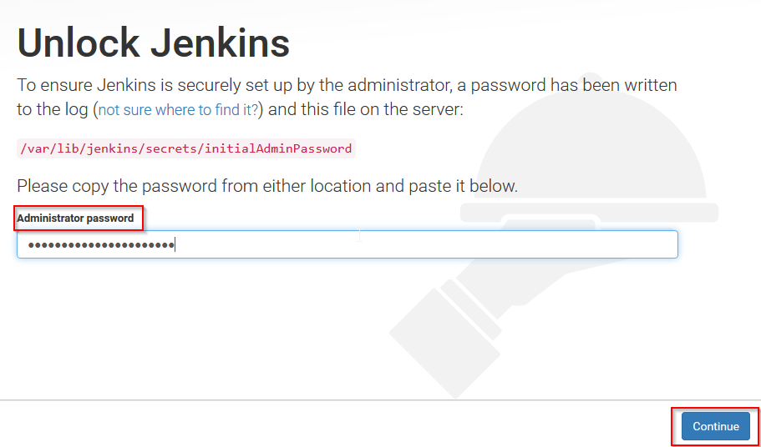

1. Click “Install Suggested Plugins”  
   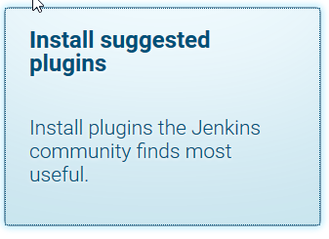
2. Create a new user:  
   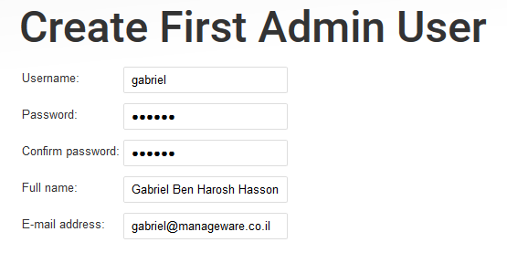
3. Click “Save and Finish”
4. Click “Start using Jenkins”

# Create the CompileNodeJS job

1. Click “New Item”  
   
2. Give the project the name “CompileNodeJS”, select “Freestyle project” and click OK.  
   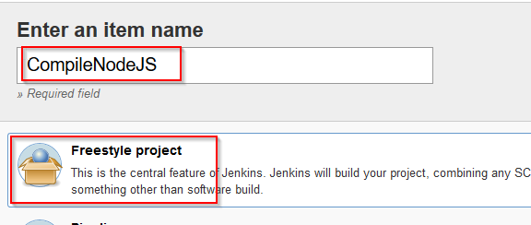
3. In the project configuration page go to the “Source Code Management” section:  
   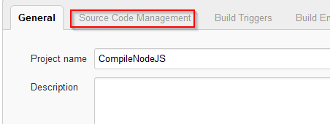
4. Select “Git” and copy the following URL to the “Repository URL” field:  
   https://github.com/sbstjn/node-kickstart  
   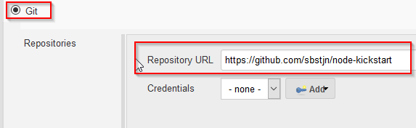
5. Go to the “Build” section, click “Add build step” and select “Execute shell”  
   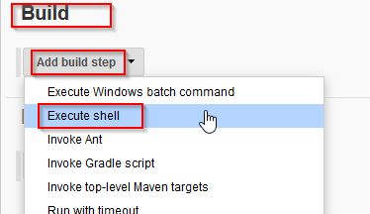
6. In the “Command” filed enter: npm install kickstart  
   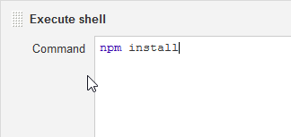
7. Save the job
8. In the project main page click “Build Now”  
   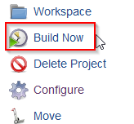
9. To view the build console click the build id:  
   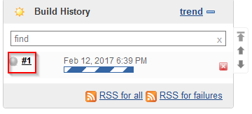
10. Click “Console Output”  
    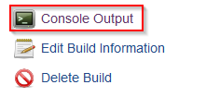

# Create the TestNodeJS job

1. Click “New Item”  
   
2. Give the project the name “TestNodeJS”, select “Freestyle project” and click OK.  
   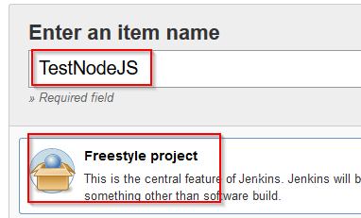
3. In the project configuration page go to the “Source Code Management” section:  
   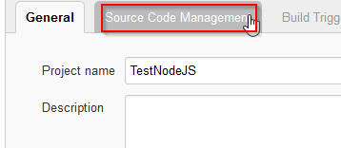
4. Select “Git” and copy the following URL to the “Repository URL” field:  
   https://github.com/sbstjn/node-kickstart  
   
5. Go to the “Build” section, click “Add build step” and select “Execute shell”  
   
6. In the “Command” filed enter: npmtest  
   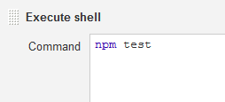
7. Save the job
8. In the project main page click “Build Now”  
   
9. To view the build console click the build id:  
   
10. Click “Console Output”  
    

# Create a Pipeline Job

1. Click “New Item”  
   
2. Give the project the name “NodeJSPipeline”, select “Pipeline” and click OK.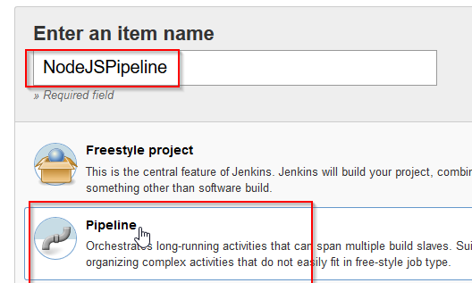
3. Go to the “Pipeline” section:  
   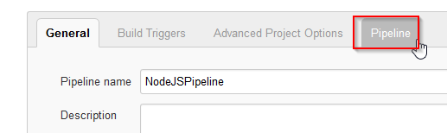
4. In the “Pipeline” section, make sure “Definition” filed is set to “Pipeline script” and copy the following text to the “Script” field:  
   node {  
    stage('Compile NodeJS'){  
    build 'CompileNodeJS'  
    }  
    stage('Test NodeJS'){  
    build 'TestNodeJS'  
    }  
   }  
     
   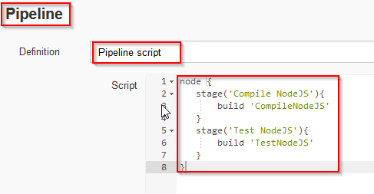
5. Save the project.
6. View the job Progress:  
   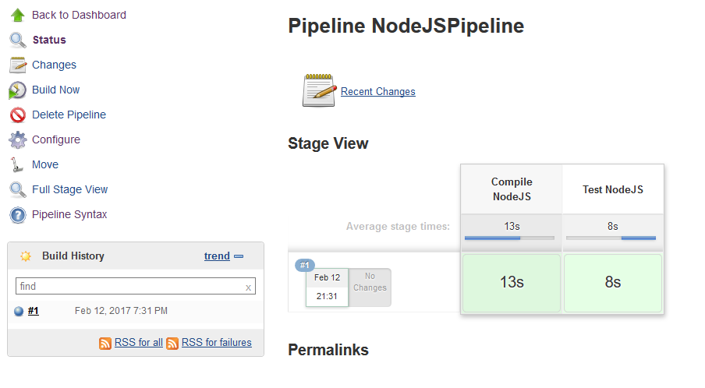

# Parameterized Build

1. Go to the CompileNodeJS project
2. Click “Configure”  
   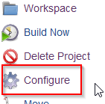
3. In the “General” stage click “This project is parameterized”  
   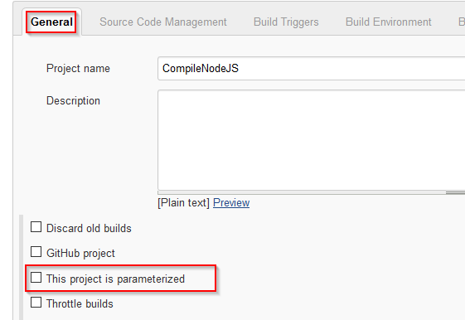
4. In the “Add Parameter” section select “Multi-line String Parameter”  
   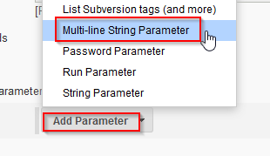
5. Give the new parameter a Name and a Default value:  
   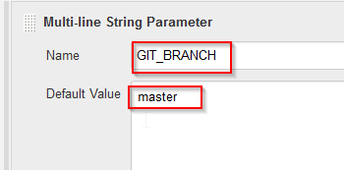
6. Go to the “Source Code Management” section, replace the “master” with the new parameter:  
   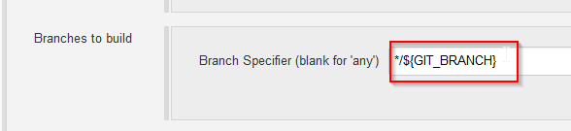
7. Save the project
8. To build the project click “Build with Parameters”:  
   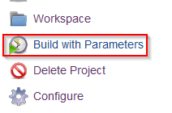
9. Enter a value to the parameter other than “master” and click “Build”:  
   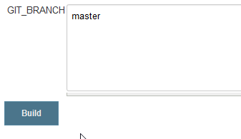
10. Check the console for the error.
11. Fix the branch name and build again.